UI/UX Design Document

Project: DeepFake Detection for images and videos

Team: Starks

Date: January 24, 2024

**User Research Insights**

* Users need to easily filter out the DeepFakes from the analysis of AI trained detectors.
* Users desire interactive visualizations to understand the DeepFake and its detection.
* Users appreciate proactive suggestions for choosing suitable detectors for the detection.
* Users' express concerns about data privacy and security, which is predominant in the case of DeepFakes.

**User Personas:**

* Multiple Detectors: By using multiple detectors, we provide flexibility for detection.
* Interactive UI: Uses the tool to priorities customer interactions and address negative sentiments promptly.

**Wireframes and Mockups (Created in Figma)**

**Link to Figma File: (Direct implementation were made, no involvement of Figma – Designs different from initial plan)**

**Key Screens:**

* Display Page: Displays Deepfake analysis results in a clear and visually appealing format, including charts, graphs, and key metrics.
* Result / Graph: Visualizes multiple detectors analysis at a time.

*Sample figma images:*

*REACT UI: -*

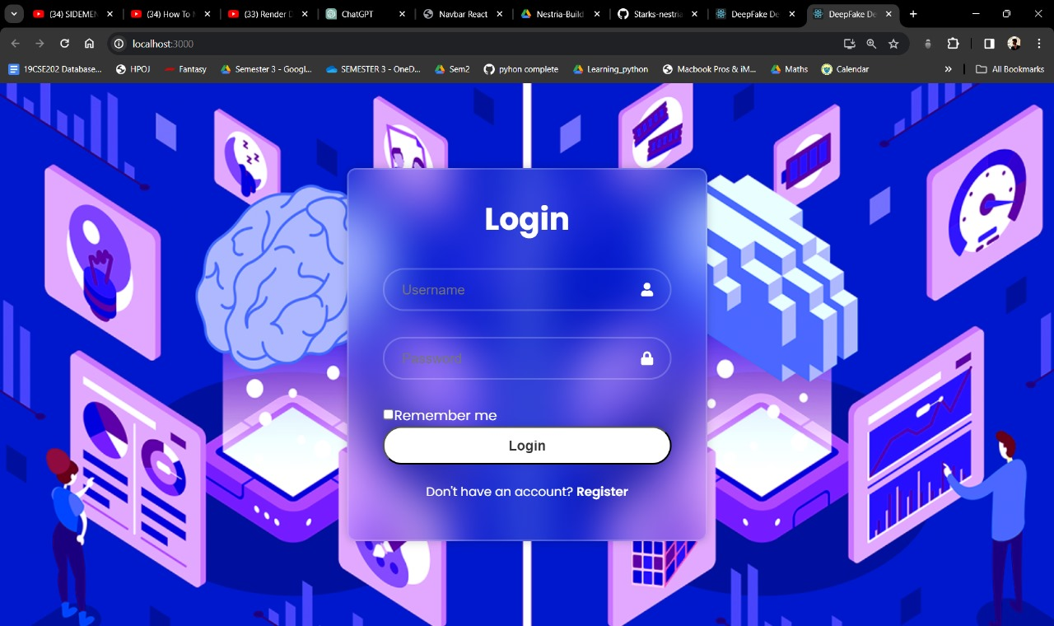

**User Flow Maps**

**Key User Flows:**

* Entering the UI: User logs in, navigates to the Main page and uploads image or videos to be detected.
* Choosing the Detector: User selects the detectors based on their knowlodge or by the suggestions we provide.
* Analysis Page: User views the graphs/result for the analysis from the detector chosen.

*Sample user flow map:*

